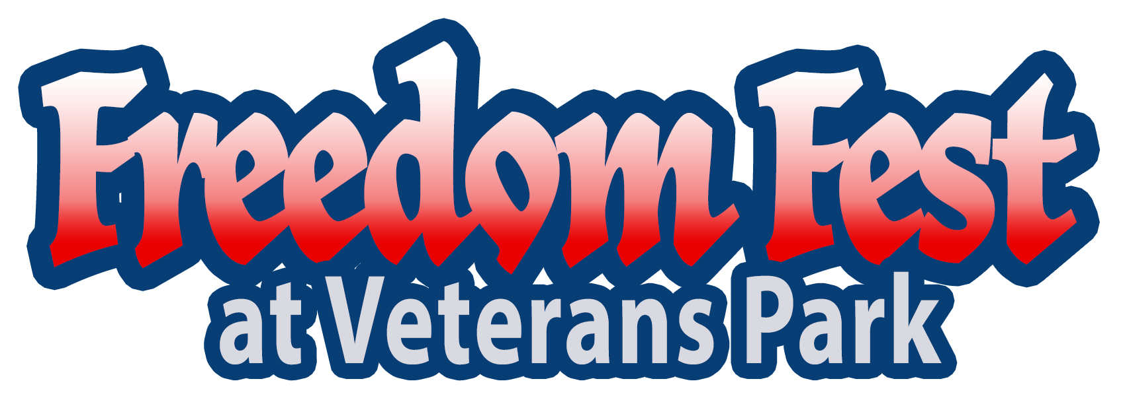

Featuring TUB – Texas Unlimited Band
& The Lost Cause Band
Free – Music Concert - bring your lawn chairs
Friday, July 3, 2023 – Activities begin at 6PM
200 Raymond St. and N. Montgomery
Sponsorship Information
Red Sponsor $500
White Sponsor $250
Blue Sponsor $100
Name______________________________________________
Address___________________________________________
Email______________________________________________
Giddings Area Chamber of Commerce
183 E. Hempstead
Giddings, Texas 78942
www.giddingstx.com
979.540.8350



